# DNS

Domain Name System is het telefoonboek van het internet. Sites zijn te bereiken via domein namen zoals www.google.com. DNS vertaalt domein namen naar ip adressen zodat browsers de resources kunnen laden.

## The 8 steps in a DNS lookup:

1. A user types ‘example.com’ into a web browser and the query travels into the Internet and is received by a DNS recursive resolver.
2. The resolver then queries a DNS root nameserver (.).
3. The root server then responds to the resolver with the address of a Top Level Domain (TLD) DNS server (such as .com or .net), which stores the information for its domains. When searching for example.com, our request is pointed toward the .com TLD.
4. The resolver then makes a request to the .com TLD.
5. The TLD server then responds with the IP address of the domain’s nameserver, example.com.
6. Lastly, the recursive resolver sends a query to the domain’s nameserver.
7. The IP address for example.com is then returned to the resolver from the nameserver.
8. The DNS resolver then responds to the web browser with the IP address of the domain requested initially.

Once the 8 steps of the DNS lookup have returned the IP address for example.com, the browser is able to make the request for the web page:

1. The browser makes a [HTTP](https://www.cloudflare.com/learning/ddos/glossary/hypertext-transfer-protocol-http/) request to the IP address.
2. The server at that IP returns the webpage to be rendered in the browser (step 10).

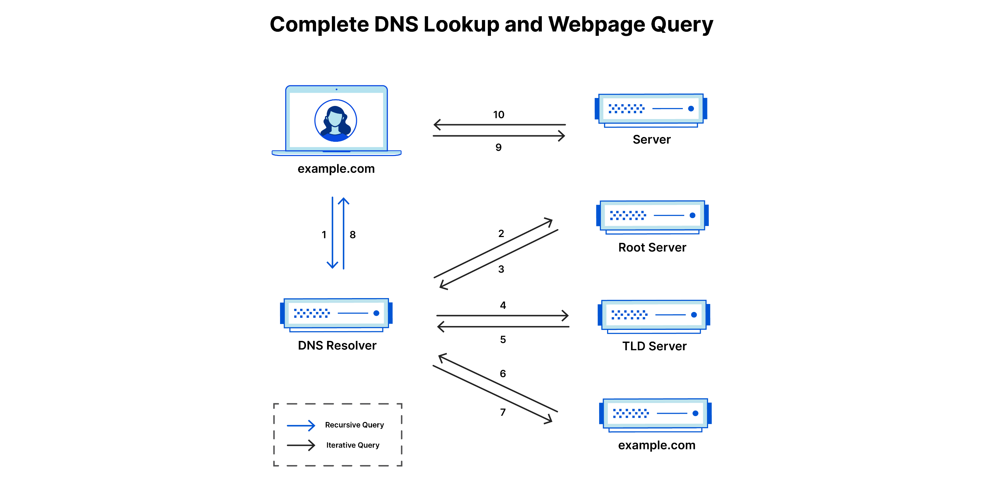

## DNS Nameservers.

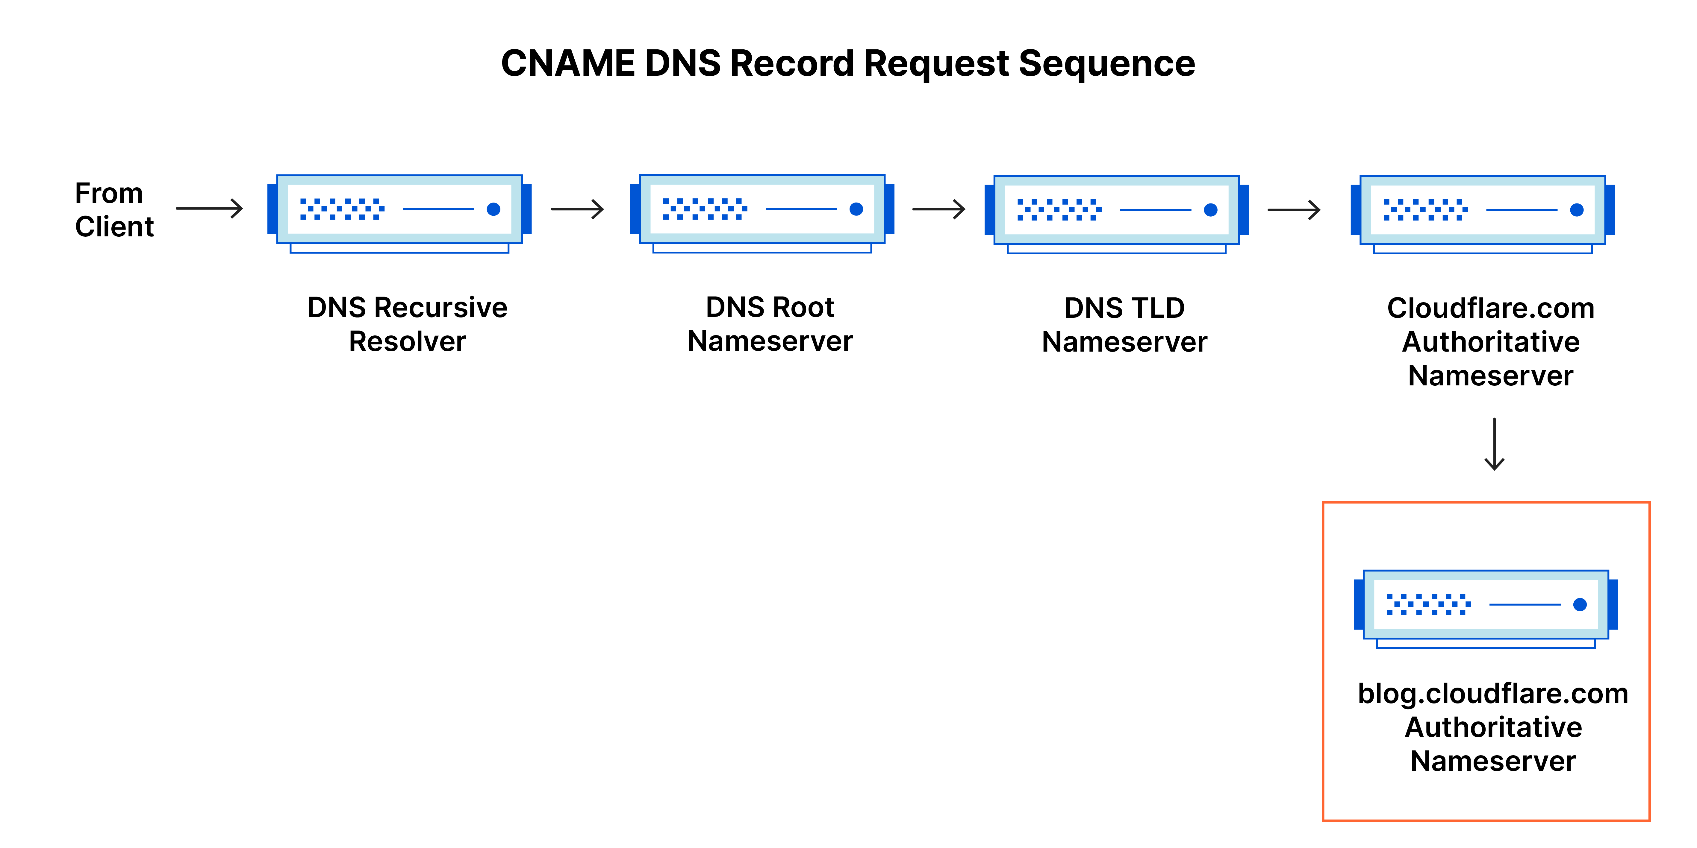

1. DNS Recursor (Recursive Resolver):
   * This is not technically a nameserver, but rather a server that handles the client's request and performs the full DNS lookup.
   * It queries other nameservers on behalf of the client to resolve domain names
2. Root Nameserver:
   * The first step in the DNS hierarchy.
   * Provides information about Top-Level Domain (TLD) servers.
3. TLD Nameserver:
   * Responsible for specific top-level domains (.com, .org, etc.).
   * Directs queries to the authoritative nameservers for specific domains.
4. Authoritative Nameserver:
   * The final authority for a specific domain.
   * Holds and provides the actual DNS records (like IP addresses) for domains. The DNS recursor is not a nameserver itself, but rather the component that communicates with these different types of nameservers to resolve DNS queries. It's the server that performs the recursive lookup, querying each level of the DNS hierarchy as needed

## DNS Records (A, CNAME, TXT, etc.)

CNAME records create an alias from one domain name to another. They essentially say, "This domain name is an alias for that domain name."

1. **DNS Resolution Process**:
   * When a DNS resolver encounters a CNAME record, it restarts the query using the canonical name provided in the CNAME record.
   * This process continues until an A record (for IPv4) or AAAA record (for IPv6) is found, which provides the actual IP address.
   * They're commonly used to point multiple subdomains to a single location without duplicating A records.
2. A (Address) Record:
   * Maps a domain name to an IPv4 address
   * Example: example.com. IN A 192.0.2.1
3. AAAA (IPv6 Address) Record:
   * Maps a domain name to an IPv6 address
   * Example: example.com. IN AAAA 2001:db8::1
4. CNAME (Canonical Name) Record:
   * Creates an alias from one domain name to another
   * Example: [www.example.com](http://www.example.com/). IN CNAME example.com.
5. MX (Mail Exchanger) Record:
   * Specifies mail servers responsible for handling email
   * Example: example.com. IN MX 10 mail.example.com.
6. TXT (Text) Record:
   * Stores text-based information, often used for domain verification
   * Example: example.com. IN TXT "v=spf1 include:_spf.example.com ~all"
7. NS (Name Server) Record:
   * Delegates a DNS zone to a set of authoritative name servers
   * Example: example.com. IN NS ns1.example.com.
8. PTR (Pointer) Record:
   * Maps an IP address to a domain name (reverse DNS lookup)
   * Example: 1.2.0.192.in-addr.arpa. IN PTR example.com.
9. SOA (Start of Authority) Record:
   * Contains administrative information about the DNS zone
   * Example: example.com. IN SOA ns1.example.com. admin.example.com. (  
     2023111501 ; serial  
     3600 ; refresh  
     1800 ; retry  
     604800 ; expire  
     86400 ) ; minimum TTL
10. SRV (Service) Record:
    * Specifies location of servers for specific services
    * Example: _sip._tcp.example.com. IN SRV 10 60 5060 sip.example.com.
11. CAA (Certification Authority Authorization) Record:
    * Specifies which Certificate Authorities can issue SSL/TLS certificates for a domain
    * Example: example.com. IN CAA 0 issue "letsencrypt.org"

SrgHfKXvnyKc

